Taking Action on a Business Time Off Requests in SuccessFactors Quick Reference Guide
Last Updated: 9/8/2022

This guide outlines the steps required to take action (approve or decline) and audit a Time Off request. Business Time Off request are routed through a variety of approvers, as appropriate based on the request type. A typical workflow includes: Business Office, Department Head, DFA, Dean, Central HR (leaves group), Sponsored Programs and Provost Office/Graduate School.

For additional information concerning Time Off policies and procedures, please refer to the Purdue Human Resources Benefits website: https://www.purdue.edu/hr/Benefits/currentEmployees/leaves/leaves.html

Note: The Time Off request feature does not replace conversations and planning between employees and supervisors.

Contents
Notification 1
Accessing SuccessFactors 1
Supervisors with Multiple Positions 2
Reviewing and Taking Action on Requests 2
Viewing Additional Request Details Before Declining or Approving 4
Editing The Request 5
Delegating Requests 7
Business Time Off Request Audits to be completed by Business Office Staff 8

Notification
When a Time Off Request is submitted, approvers receive an email notification requesting review and action.  Click the link in the notificaiton to be taken directly to the request to be reviewed, or access SuccessFactors using the instrucitons in the next section of this document. | 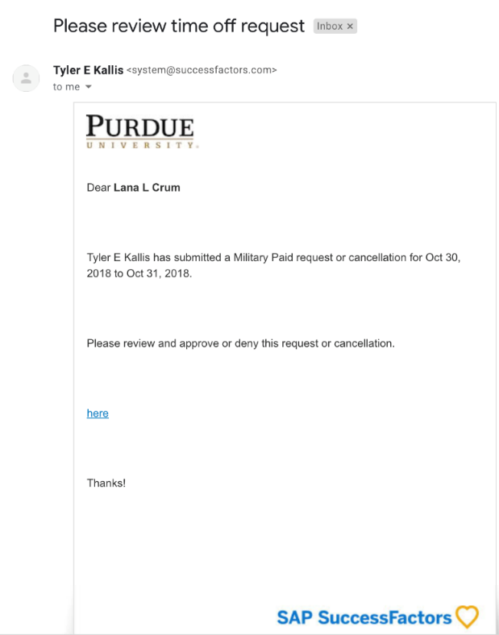

Accessing SuccessFactors
Visit OneCampus and select Employee Launchpad. |  |  | https://one.purdue.edu/  
Log in using Purdue Career Account ID and BoilerKey passcode.  For assistance using or setting up BoilerKey, please contact ITaP at itap@purdue.edu or 765-494-4000. |  |  | 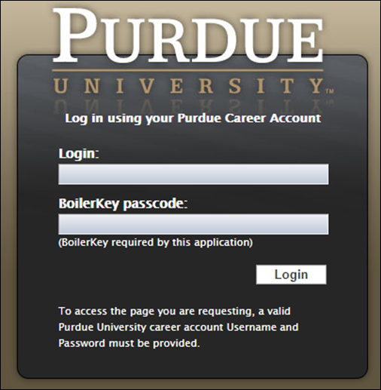

Supervisors with Multiple Positions
Supervisors with more than one appointment will have to switch to other account(s) to view pending actions that fall under those appointments by clicking the Change Selected Employment icon on the Navigation bar. |  | 

Reviewing and Taking Action on Requests
After logging in to SuccessFactors, anything requiring approval can be found under Approvals (beneath Quick Actions)  Like-requests are stacked. To view them all click View All. To approve click green check mark; to decline click red check mark  You can also view the Workflow list via the checkmark next to search   |  | 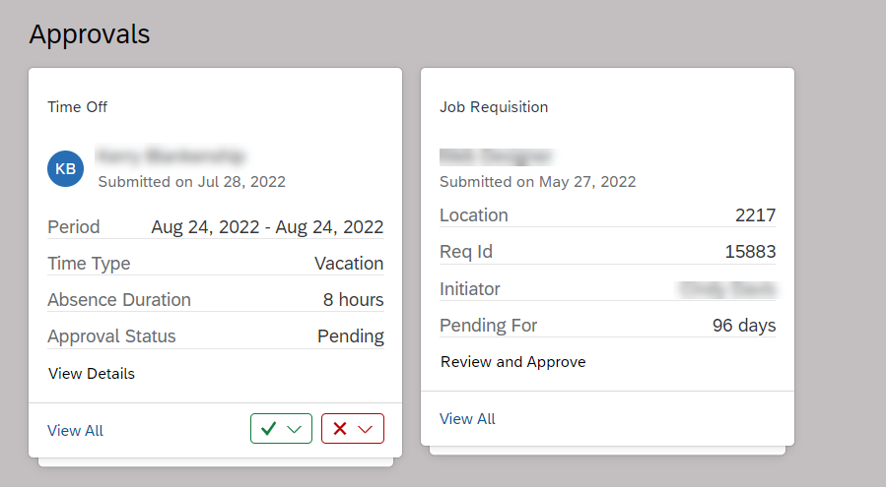
Click the icon to view in the format of Workflow Request |  | 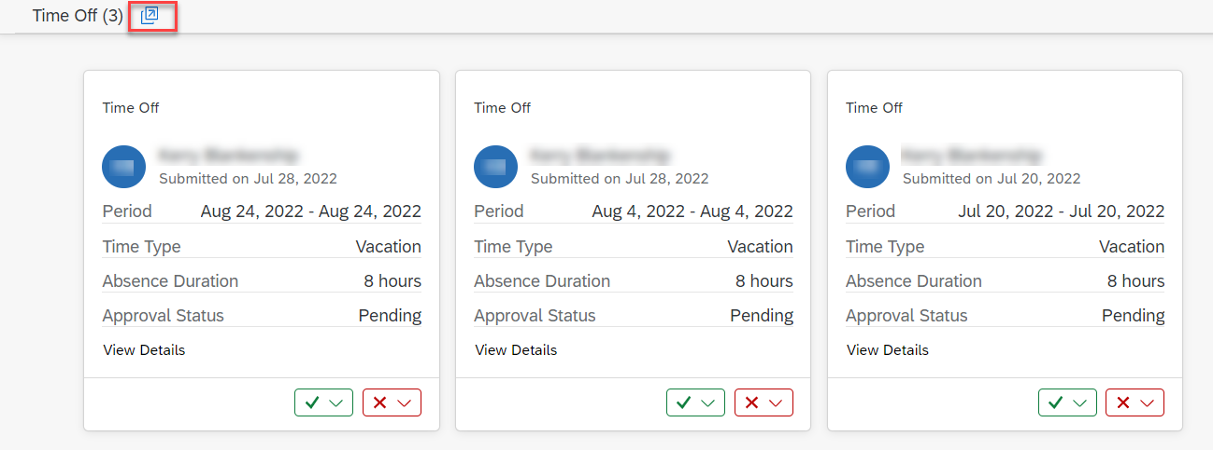
Click the “Employee Time for…” link to see the details of the request. |  | 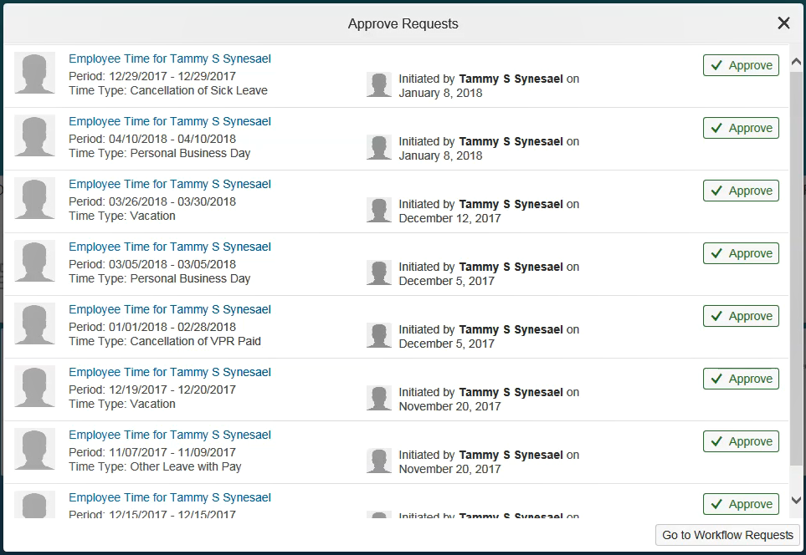

Viewing Additional Request Details Before Declining or Approving
View the details of the request by clicking on “Employee Time” request title.
All details of the request, including any attachments, are available for review.  Note: Business Office staff are required to audit a variety of items when taking action on a Business Time Off request. See last page of this document Business Time Off Request Audits to be completed by Business Office Staff for a full list of items that must be audited.  To edit the request, see Editing the Request (next section in this document) |  | 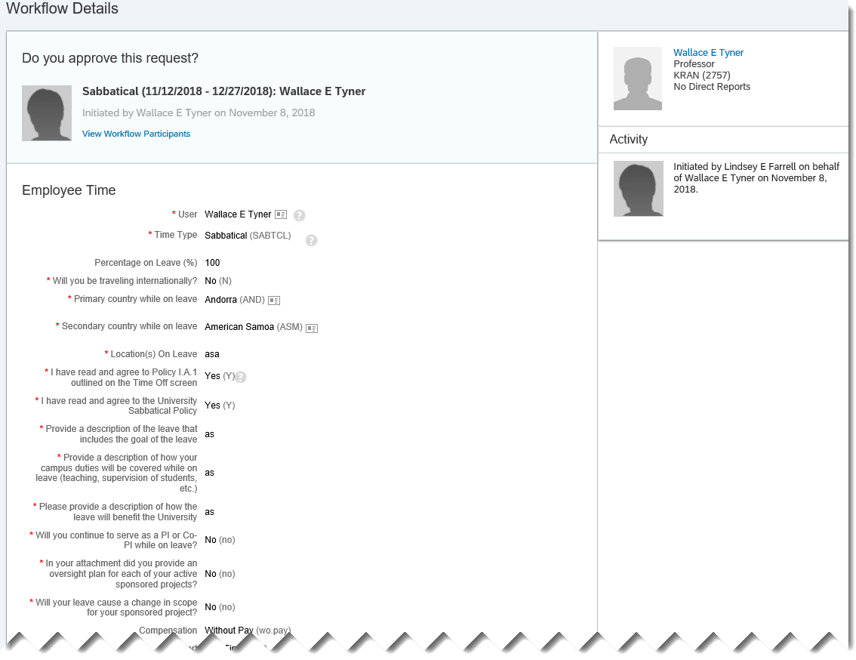
- The Team Absence Calendar is available.  - The Comment feature can be used to send a note back to the employee. You must click Post to send the comment. A comment can be posted without Approving or Declining.  - When ready to take action, click Approve or Decline. The employee will be notified in SuccessFactors and via email.  See the Delegating Requests section of this document for instructions on delegating the approval to another individual. |  | 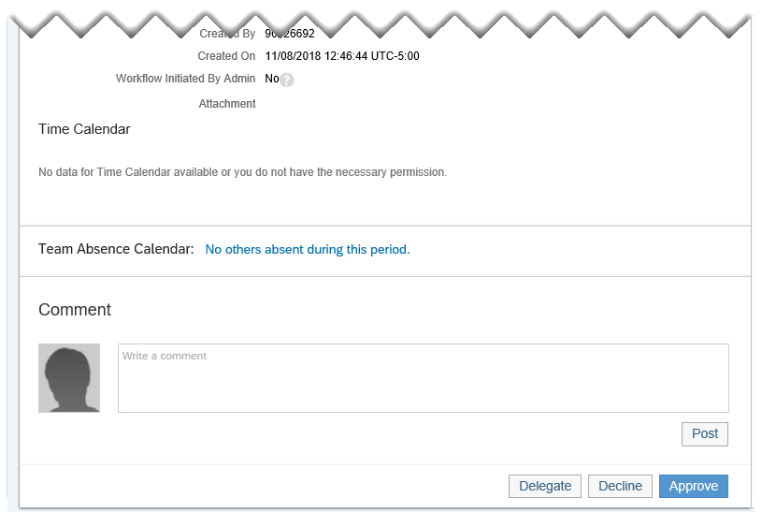  3  2  1

Editing The Request
The Budget Approver, DFA and Central HR (leaves group) all have the ability to edit the time off request.  On the Workflow Details page (provides details of the request and attachments), click the Requester’s name – found in the upper right corner. |  | 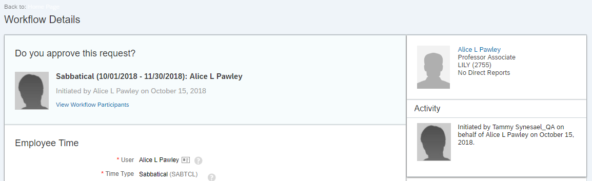
On the employee’s profile, Click the Time Off tab  Click Administer Time |  | 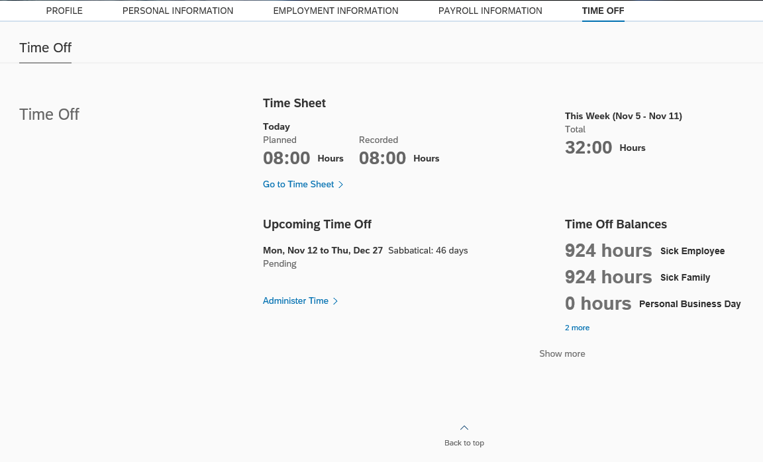
Time Information screen displays.  Click the pencil icon next to the request to be edited. |  | 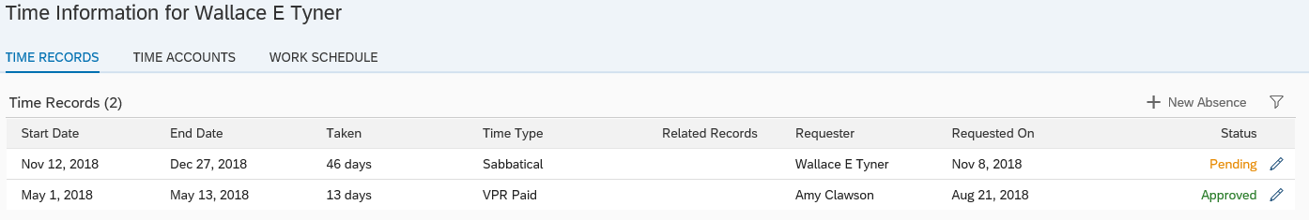
Make edits as necessary  Click Submit |  | 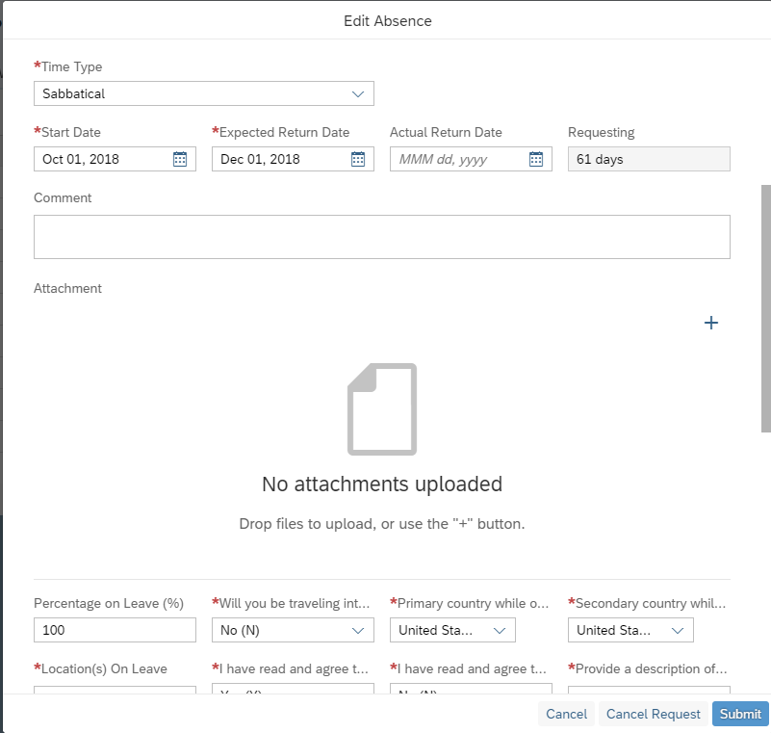
In order to finalize your approval, return to the SuccessFactors home screen to access the Approve Requests tile again. Repeat the steps found in the Viewing Additional Request Details Before Declining or Approving section of this document.

Delegating Requests
Click the “Employee Time for…” link for the request. | 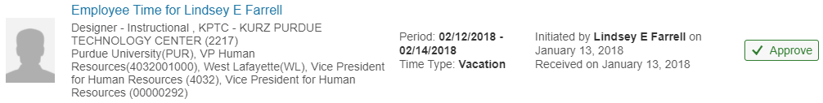
At the bottom of the details screen, click Delegate. | 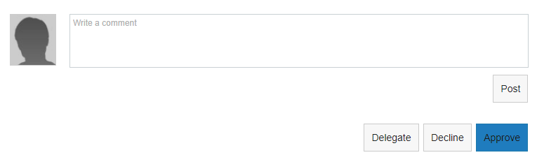
- Complete the field to indicate to whom you wish to delegate.  The field can be completed using the drop down menu, or by typing a name to perform a search.  - Click Send.  - On the next screen, verify that you would like to Delegate. | 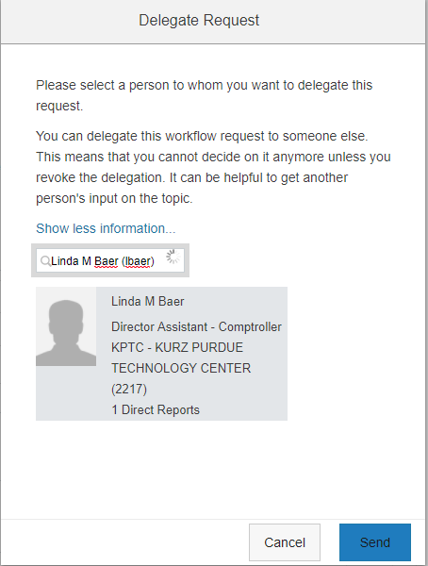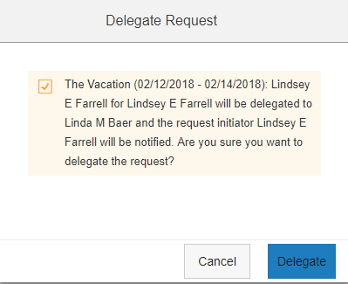  3  2  1
The supervisor to whom you delegated will see the request in their queue.  The request indicates from whom it has been delegated.  The employee will be notified that the request has been delegated and to whom.  Tip: If you want to delegate all workflows, which includes but is not limited to leave requests, you can do so by using Auto Delegate. | 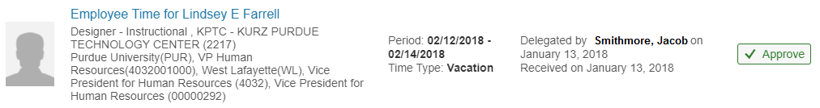

Business Time Off Request Audits to be completed by Business Office Staff
These audits are to be completed by the business office staff who receive the requests as part of the workflow.
Applicable Policies:
- Sabbatical Leave of Absence (B-11)
- Outside Activity Guidelines
  - Conflicts of Commitment and Reportable Outside Activities Policy (III.B.1)
  - VPEC Conflict of Commitment and Reportable Outside Activities Policy FAQ

Items to audit:
- If concurrently employed ensure all positions reflect the leave being request.

- Is the correct leave type being requested (Sabbatical, Research/Instructional/Engagement, Outside Activity Leave)?
  - If requesting a multiple leave, such as Sabbatical and Research/Instructional/Engagement, the Sabbatical leave is the primary request and the Research/Instructional/Engagement leave is addressed in ALL comment sections with FTE for each respective leave indicated?

- Compensation/Funding
  - Are the correct account numbers listed (for paid or unpaid)?
  - Is the correct compensation being requested (paid, partial paid, unpaid)?
  - If there is a change in FTE, is the new FTE calculated correctly?

- Is the description of leave thorough (why leave is being requested/what will they be doing/what is to be accomplished/etc. Do not just list an itinerary.)?

- Is the graduate staff information filled out (Monthly salary/stipend, supervisor, credit hours)?

- Leave type-specific considerations
- Sabbatical
  - Is the faculty member is eligible (tenured, time worked)?
  - Do the dates of the leave correspond to the academic calendar?
  - If applicable, is the Administrative Supplement listed?

- Outside Activity Leave
  - Verify that a Reportable Outside Activity form has been completed/submitted.

- Research/Instructional/Engagement and/or Change in Duty Station
  - Know the definition of this type of leave. It is often confused with Change in Duty Station. If the leave/destination has ANY work/research benefit at all, it is a Research/Instructional/Engagement leave.
  - The purpose of these leaves is often confused. Validate that the appropriate leave has been selected, based on policy.

- Determine if leave is greater than, less than, or equal to 22 working days.
  - Count the number of WORKING DAYS (do not include weekends/holidays). The number of working days requested impacts the individuals to be included in the approval workflow.

